**Создайте SSIS пакет с добавлением данных (10 новых пловцов) в таблицу Swimmer из AdventureWorksDW2017.dbo.DimEmployee или из своего сгенерированного  файла. Используйте задачу OLE DB.**

**Вариант 1**

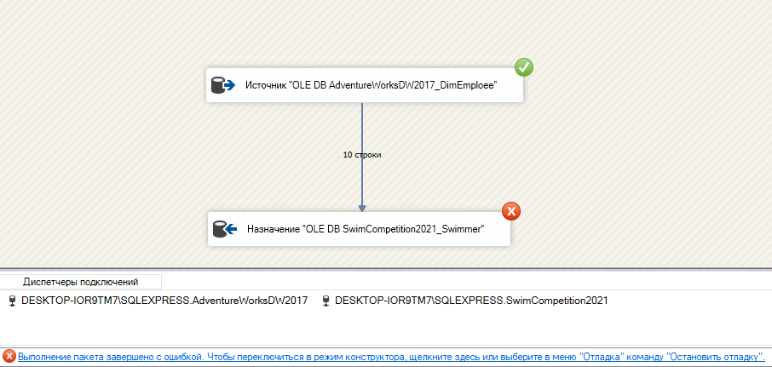

|  |
| --- |
| Ошибка: 0xC0202009 в Задача потока данных, Назначение "OLE DB SwimCompetition2021_Swimmer" [41]: SSIS Error Code DTS_E_OLEDBERROR. An OLE DB error has occurred. Error code: 0x80004005. |
| Ошибка: 0xC0209029 в Задача потока данных, Назначение "OLE DB SwimCompetition2021_Swimmer" [41]: SSIS Error Code DTS_E_INDUCEDTRANSFORMFAILUREONERROR. The "Назначение "OLE DB SwimCompetition2021_Swimmer".Входы[Вход назначения "OLE DB"]" failed because error code 0xC020907B occurred, and the error row disposition on "Назначение "OLE DB SwimCompetition2021_Swimmer".Входы[Вход назначения "OLE DB"]" specifies failure on error. An error occurred on the specified object of the specified component. There may be error messages posted before this with more information about the failure. |
| Ошибка: 0xC0047022 в Задача потока данных, SSIS.Pipeline: SSIS Error Code DTS_E_PROCESSINPUTFAILED. The ProcessInput method on component "Назначение "OLE DB SwimCompetition2021_Swimmer"" (41) failed with error code 0xC0209029 while processing input "Вход назначения "OLE DB"" (54). The identified component returned an error from the ProcessInput method. The error is specific to the component, but the error is fatal and will cause the Data Flow task to stop running. There may be error messages posted before this with more information about the failure. |

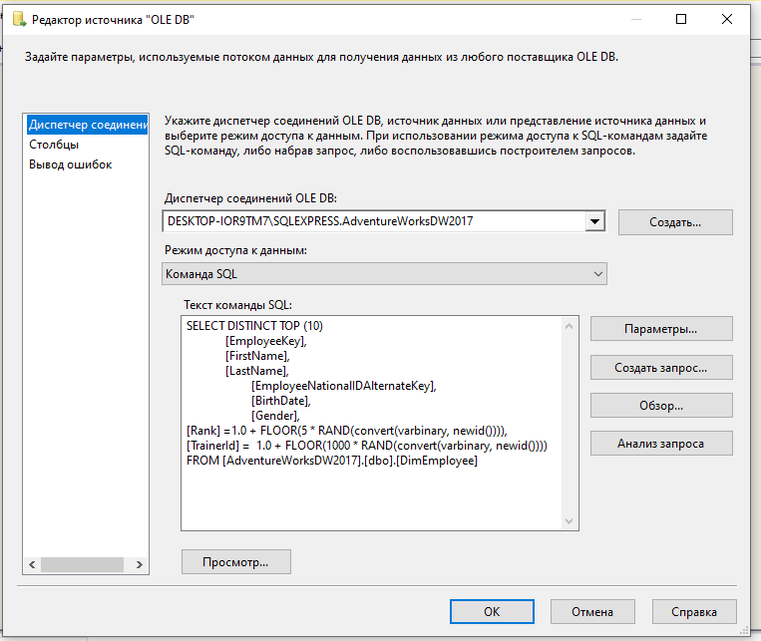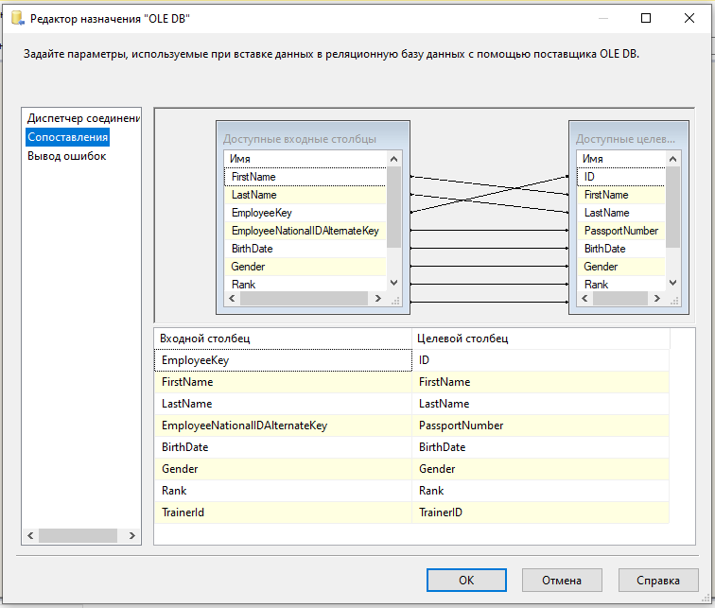

**Вариант 2**

**Во втором случае используется файл с идентичными параметрами, но все равно выдает ошибку.**

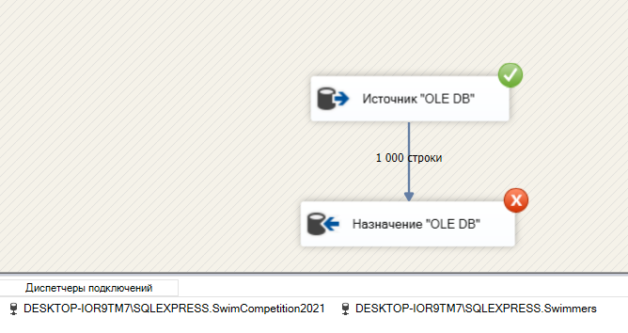

|  |
| --- |
| Ошибка: 0xC0202009 в Задача потока данных, Назначение "OLE DB" [41]: SSIS Error Code DTS_E_OLEDBERROR. An OLE DB error has occurred. Error code: 0x80004005. |
| Ошибка: 0xC0209029 в Задача потока данных, Назначение "OLE DB" [41]: SSIS Error Code DTS_E_INDUCEDTRANSFORMFAILUREONERROR. The "Назначение "OLE DB".Входы[Вход назначения "OLE DB"]" failed because error code 0xC020907B occurred, and the error row disposition on "Назначение "OLE DB".Входы[Вход назначения "OLE DB"]" specifies failure on error. An error occurred on the specified object of the specified component. There may be error messages posted before this with more information about the failure. |
| Ошибка: 0xC0047022 в Задача потока данных, SSIS.Pipeline: SSIS Error Code DTS_E_PROCESSINPUTFAILED. The ProcessInput method on component "Назначение "OLE DB"" (41) failed with error code 0xC0209029 while processing input "Вход назначения "OLE DB"" (54). The identified component returned an error from the ProcessInput method. The error is specific to the component, but the error is fatal and will cause the Data Flow task to stop running. There may be error messages posted before this with more information about the failure. |

